|  |  |
| --- | --- |
|  | **2013** |
|  | FollowME  Alexei Sragovich, Alex Tilkin, Lior Solomon |

|  |
| --- |
| **[followme]** |
| Emerging Web and Mobile Technologies, Part 1 |

Team members

|  |  |  |  |
| --- | --- | --- | --- |
| Name | Phone Number | E-mail | ID |
| Alexei Sragovich | +972544673555 | [sr.alexei@gmail.com](mailto:sr.alexei@gmail.com) | 316709260 |
| Alex Tilkin | +972544548491 | [alextilk@gmail.com](mailto:alextilk@gmail.com) | 304413529 |
| Lior Solomon | +972525422792 | liorsolo@gmail.com | 036630960 |

# Contents

Contents 1

Figures 2

Functional requirements 3

Non-Functional requirements 4

Performance 4

Accessibility 4

Usability 4

Testability 4

Application Social Network 4

User Characteristic 5

Potential Customers (Companies and Organizations) 5

Processes 6

Create a path from one point to another 6

Set a Follower 7

Send Location to another User 8

Sign Up 9

Log In 10

Placing an Event on the map 11

Get All Nearby Events 12

Notify About an Emergency 13

Add Friend 14

MongoDB Architecture 14

Market Analysis 15

Family Tracker 15

FootPrints 15

# Figures

Figure 1 - Path creation process 6

Figure 2 - Set a follower 7

Figure 3 - Send location to another user 8

Figure 4 - Sign In process 9

Figure 5 - Log In process 10

Figure 6 - Set event on the map 11

Figure 7 - Get All Nearby Events 12

Figure 8 – Notify about the emergency 13

Figure 9 - Add friend 14

# Functional requirements

* The application is for registered users only
* The email addresses will be used as the unique user name
* The user will be able to see his location on the map (over a website) using his phone's GPS
* The user can create a path on the map from point A to point B
* The user can delete the path
* The user can send his path to other user
* The user can send his current location to other user without notify all the other users that nearby
* The user can select a location on the map and place a mark; all nearby (in radius of not more than 50 meters) users will be able to see his mark. i.e., a user marked in his current location "Fire" (He sees a fire), than all nearby users will see his notification
* All marks that users put will be deleted automatically after one day
* The user can delete mark from the map, even if he wasn’t the one who put it there
* The registration will be through web
* The user cannot send other media data such as audio, video, images except those who allowed in the application
* The user can inform that he arrived to the desired destination and he is safe
* The user has the ability to inform of an alert in case a danger is approaching. Alert notifications will be received by both followers (private and nearby followers). In case a follower receives an Alert he will has the ability to perform a fast Emergency call
* The user can add friends to his account
* The user can store only one path (if he decides to create a new path the current path is overridden)

# Non-Functional requirements

## Performance

Application's response will be not more than 10 seconds from the moment when the event accrued on any operation that user does

## Accessibility

In lack of resources it cannot be promised that the server will be online 100% of the time. Server will be back to work (Online mode) not more than 1 hour from the moment the issue is found

## Usability

The application is designed for the ages of 12 – 100. Since this application needs to deal with high verity of ages it will be approachable to all types of users

## Testability

The application will be easy to be tested in all related aspects: GUI, DB, GPS and network transport

# Application Social Network

Follow me, is an application that displays information regarding user's location, status and events in his area. The user will have the ability to create a path from two points on the map and share it with other users. In addition, it will have the ability to notify regarding events that he sees such as: Fire, Car accident, Electrical blackout etc.

The user will have the ability to share what he sees by text and obstacles on his way to other users.

The idea came up to provide a security to people that afraid to walk in neighborhoods at night. This application has the ability to share user's path with a family member or other friends. In addition, share events on his way with other users which nearby.

Follow me in the social network world reflected in its sharing capabilities of the user to other followers or nearby users. Those types of functionalities that mentioned above create an interaction between the users and create a social Network on the web.

# User Characteristic

The type of users that are a potential user are those who have smartphone and internet access and have the ability to browse on-line on the web, have oriented capabilities on an application and on the web.

User age can be older than 12 years old, must know English language and know how to read kind of Topological Map.

# Potential Customers (Companies and Organizations)

* FollowMe is a real-time notification web based application. The potential companies or organizations for purchasing this application are:
  + Governmental and municipalities may use this application as a service for its residence
  + A companies that develop a geo location web based oriented, social network application that interested in this type of service and don't want to invest money and time in developing this kind of service

# Processes

## Create a path from one point to another

1. The user chooses to draw a path
2. The user marks on the map the start point
3. The user chooses a point on the map in sequential order from the starting point to the destination.
4. When all points are set (the user decides when all points are set), the application will connect the set of points with lines and the path will be drawn on the map

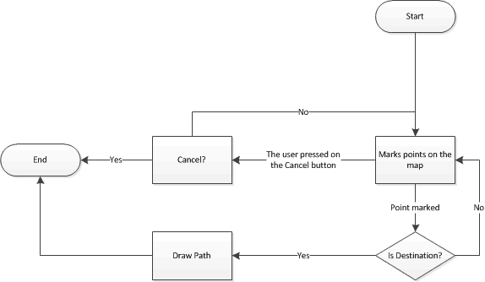

Figure 1 - Path creation process

## Set a Follower

1. The user types the desired email (user's identification field) which he wants to share with his path
2. The user clicks on the **Send** button and the path is shared with the requested user

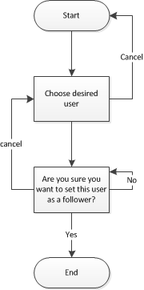

Figure 2 - Set a follower

## Send Location to another User

1. The user opens a web page and marks the desired location that maps that he wants to share
2. The user chooses a user which he wants to share with his location
3. The user clicks on the **Send** button. The location is sent to the destination

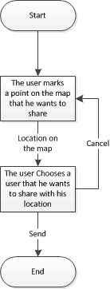

Figure 3 - Send location to another user

## Sign Up

1. The user browse to the **FollowMe** web site
2. The user clicks on the **Sign Up** button
3. The user is requested to fill a details form
4. The user clicks on the "Confirm" button in order to finish the sing up process
5. If the details failed in the verification process the system will notify the user that one of the details is wrong (return to step 4)
6. The system stores the user in the DB

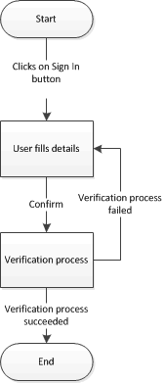

Figure 4 - Sign In process

## Log In

1. The user browse to the **FollowMe** web site
2. The users clicks on the **Log In** button
3. The user is requested to perform an authentication process which requires to fill the following fields:
   1. User name
   2. password
4. The system performs an authentication process
5. If the authentication process succeeded the user is logged into the website
6. If the authentication process failed, the user required to fill the fields: User name, password again and to do the authentication process again
7. A message will be displayed regarding the log in status

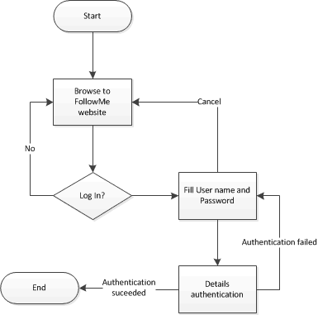

Figure 5 - Log In process

## Placing an Event on the map

1. The user clicks on a button which navigates to "Events" screen
2. The user chooses an event
3. The user can add a description regarding the mark

**Note**: Event can be placed only at the current location of the user

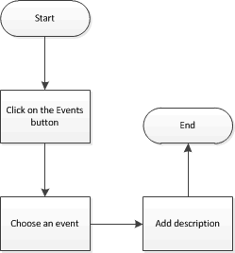

Figure 6 - Set event on the map

## Get All Nearby Events

1. Query description: get all the events collection from the **Events** collection in radius of not more than 50 meters
2. For each event, show it on the map

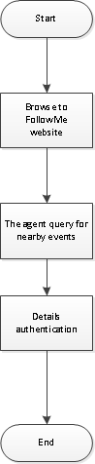

Figure 7 - Get All Nearby Events

## Notify About an Emergency

1. The user clicks on the **Emergency** button
2. An event is placed on the map at user's current location with an icon which indicates that about an emergency

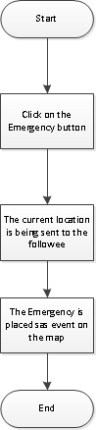

Figure 8 – Notify about the emergency

## Add Friend

1. User clicks on the Button **Add Friend**
2. User types user email (unique field)
3. Query description: query for an email
4. The user receive confirmation that the user is found
5. User clicks on the Save a Friend button
6. Query description: Insert a new document to Friends collection with current user ID and the selected user ID

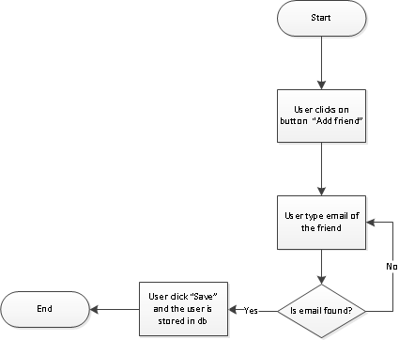

Figure 9 - Add friend

# MongoDB Architecture

The embedded file below contains a diagram that describes the architecture of the DB that will be integrated into the server of the application. **NOTE:** Since NO SQL has no standardized scheme description language, we used UML in order to describe our architecture.

**Note**: Double click on the icon below in-order to see the diagram in PNG file



# Market Analysis

## Family Tracker

"*Family Tracker is a GPS tracking application that allows you to track Android and Apple iOS devices and send free text messages between them*."

This application is actually to track a devise; the device can be iPhone or Android. This application show other devise via maps. There are more features that are includes in this application like: Free texts between phones in any language, Post your current location on Facebook, Twitter, Google+, etc. This kind of features would not be included in the Follow-Me app (at least not in the first version of the app). The user that track he device will be able to do so via web browser or the Family Tracker app itself installed on the device.

The Family tracker is an application that need to be download as an *.apk file and need to be installed on the android device, Follow-Me application is a web based application that would not ask the user for any installation.

With Follow-Me application the user will have the ability to share to other users his current path and in Family tracker application "the device" shares his location and not his path.

Follow-Me application required registering in Family tracker application the user will have 2 ways to set it up:

1. Need to install the application on 2 devices.
2. Install the application on 1 device and track this device via their web site.

With the Family tracker application the user will have the ability to send text messages. With Follow-Me application the user will have the ability to share his obstacles on his way with other users and would not have the ability to send text messages.

## FootPrints

This application helps parents track their children in real-time. The application installed on child's smartphone and on parent's smartphone. The child smartphone sends his location periodically to parents' smartphone.

**FollowMe** allows the user to define the path that the user is intent to walk through and inform other users about it.

**FootPrints** requires installation in advance while **FollowMe** is a web based where no installation is needed. Footprints is a platform dependent to iOS, while FollowMe is platform independent.